Andrew Hu

# SLIC

I implemented SLIC based on “SLIC Superpixels Compared to State-of-the-art Superpixel Methods.” by [Radhakrishna Achanta](https://ieeexplore.ieee.org/author/38485253600); [Appu Shaji](https://ieeexplore.ieee.org/author/37546517900); [Kevin Smith](https://ieeexplore.ieee.org/author/37089102239); [Aurelien Lucchi](https://ieeexplore.ieee.org/author/38230265900); [Pascal Fua](https://ieeexplore.ieee.org/author/37281288800); [Sabine Süsstrunk](https://ieeexplore.ieee.org/author/37271567600). It follows these basic steps:

1. Place clusters around the image and adjust their placement based on nearby colors
2. During each iteration, assign each pixel to the nearest cluster based on color and spatial distance, then update cluster centers to the mean
3. Enforce connectivity by merging small components, then reassign each segment

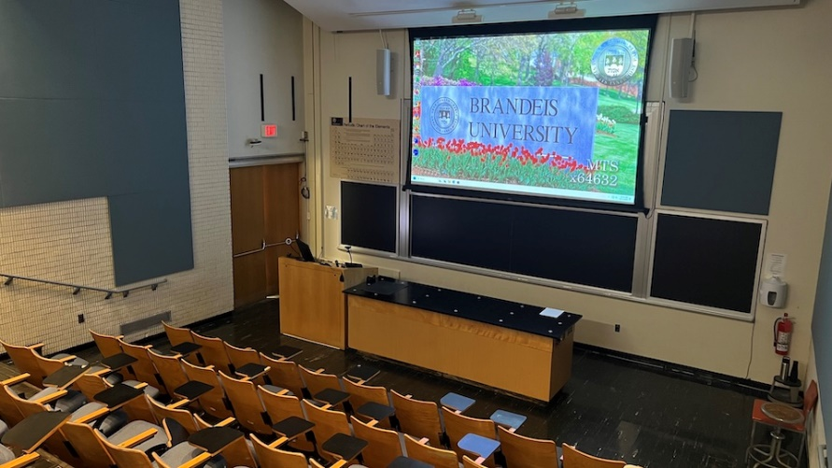

Original image

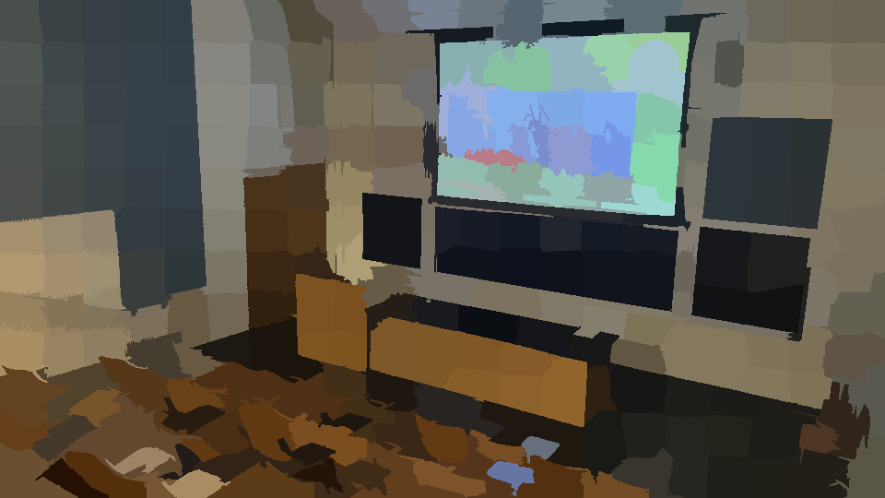

My SLIC with enforcing connectivity

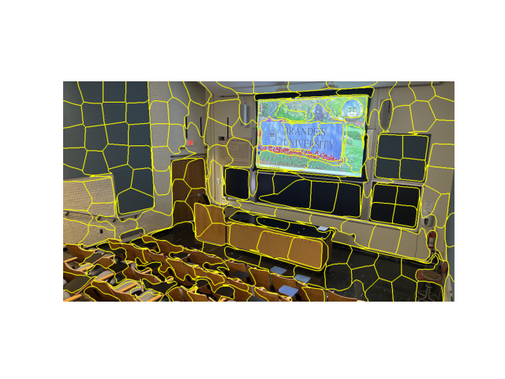

Scikit implementation from [Pyimagesearch](https://pyimagesearch.com/2014/07/28/a-slic-superpixel-tutorial-using-python/)

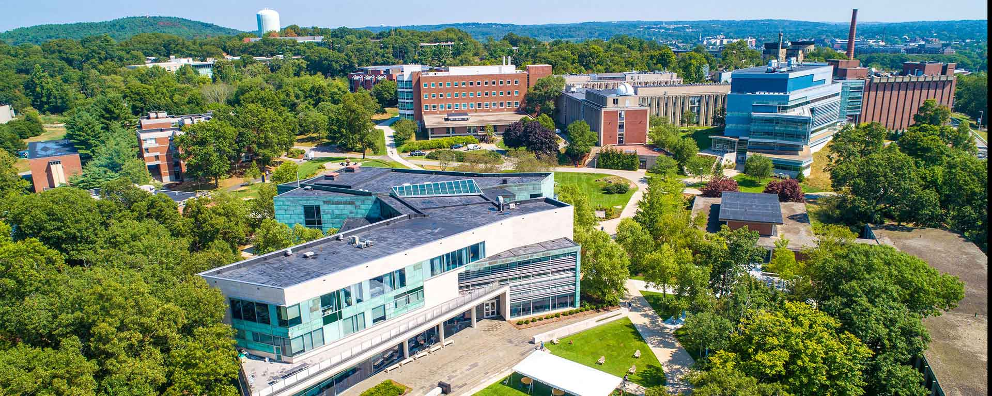

Original image 2

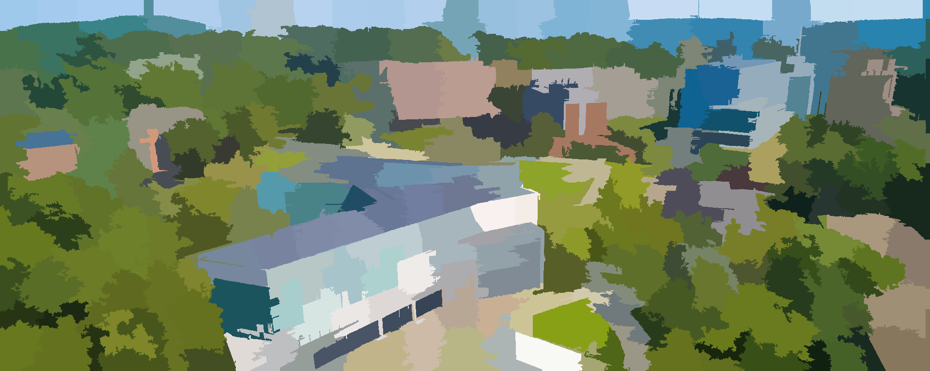

My SLIC 2

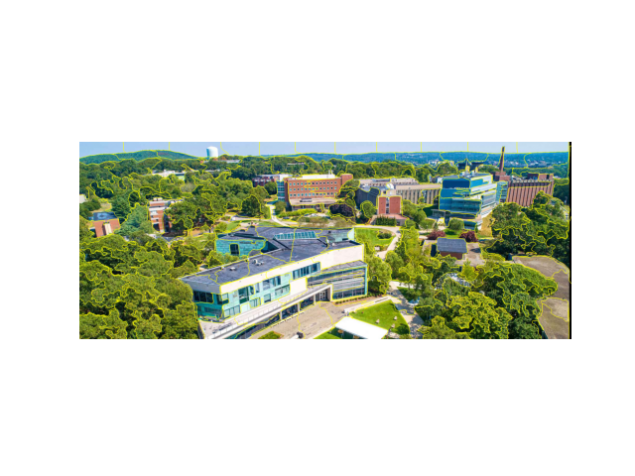

Scikit implementation 2

My implementation was slower, but that is likely because the superpixel map has a lower resolution in their implementation. The scikit implementation also has yellow lines around the superpixels instead of the mono-color visualization that I used, which is likely a better way to represent the information. I also used the gradient minimizing step from the paper, which the scikit version does not. It is not clear how much it helps, however, since the visual differences are minimal.

# Visual Attention Demo 1

I deliberately chose a low-res image with noise to test the limitations of the algorithm, and it did not perform very well.

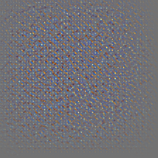

Vanilla Airedale

Airedale (0.20286)

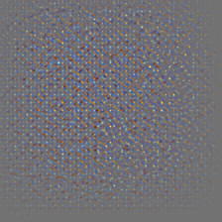

Vanilla Cocker Spaniel

cocker_spaniel (0.21997)

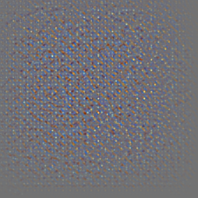

Vanilla Gordon Setter

Gordon_setter (0.03686)

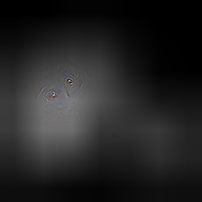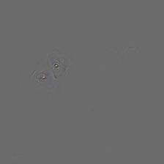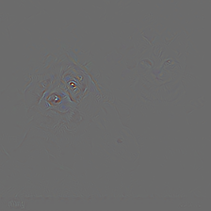

Guided Backpropagation in order: Airedale, Cocker Spaniel, Gordon Setter

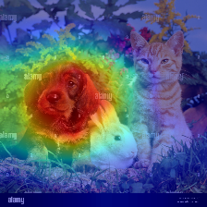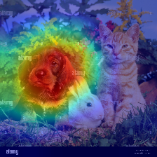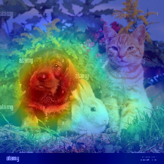

Grad-CAM

# Demo 2

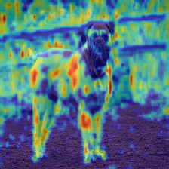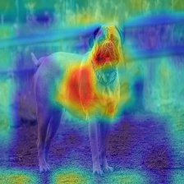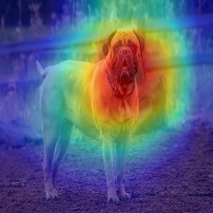

Generating Grad-CAM @relu

#0: bull_mastiff (0.97391)

Generating Grad-CAM @layer1

#0: bull_mastiff (0.97391)

Generating Grad-CAM @layer2

#0: bull_mastiff (0.97391)

Generating Grad-CAM @layer3

#0: bull_mastiff (0.97391)

Generating Grad-CAM @layer4

#0: bull_mastiff (0.97391)